## **Orientation Angle Processing**

The aim of the following tests is to see how different processing methods improved data reliability and explore their limitations.

### **Applying Offset Cancellation Values**

#### **Test Setup**

The IMU was left stationary on a flat desk, facing up and allowed to gather samples. The first set of data was gathered without applying the cancellation offsets and the second set of data obtained had the cancellation offsets applied to each sample.

#### **Results**

Figure 1 depicts graphs that contain orientation data with and without cancellation offsets applied. It can be seen that I the case of the gyroscope’s angle in all three axes, the drift is much more severe, when the offset cancellation values are not applied, with the drift in the x-axis reaching close to 2000 degrees in just over two minutes. When the offset cancellation values are applied, the drift experienced in the same axis is just over 12 degrees in over two minutes, giving drift that approximately 270 smaller.

In the case of the accelerometer, it can be seen that when the offset cancellation values are not applied, the tilt measured in the y-axis is approximately 25 degrees. This is incorrect since the accelerometer should measure a tilt close to zero when left stationary facing up. After the offset cancellation values are applied the tilt angle becomes almost zero, which is the expected output from an IMU situated at a right angle to the gravity vector.

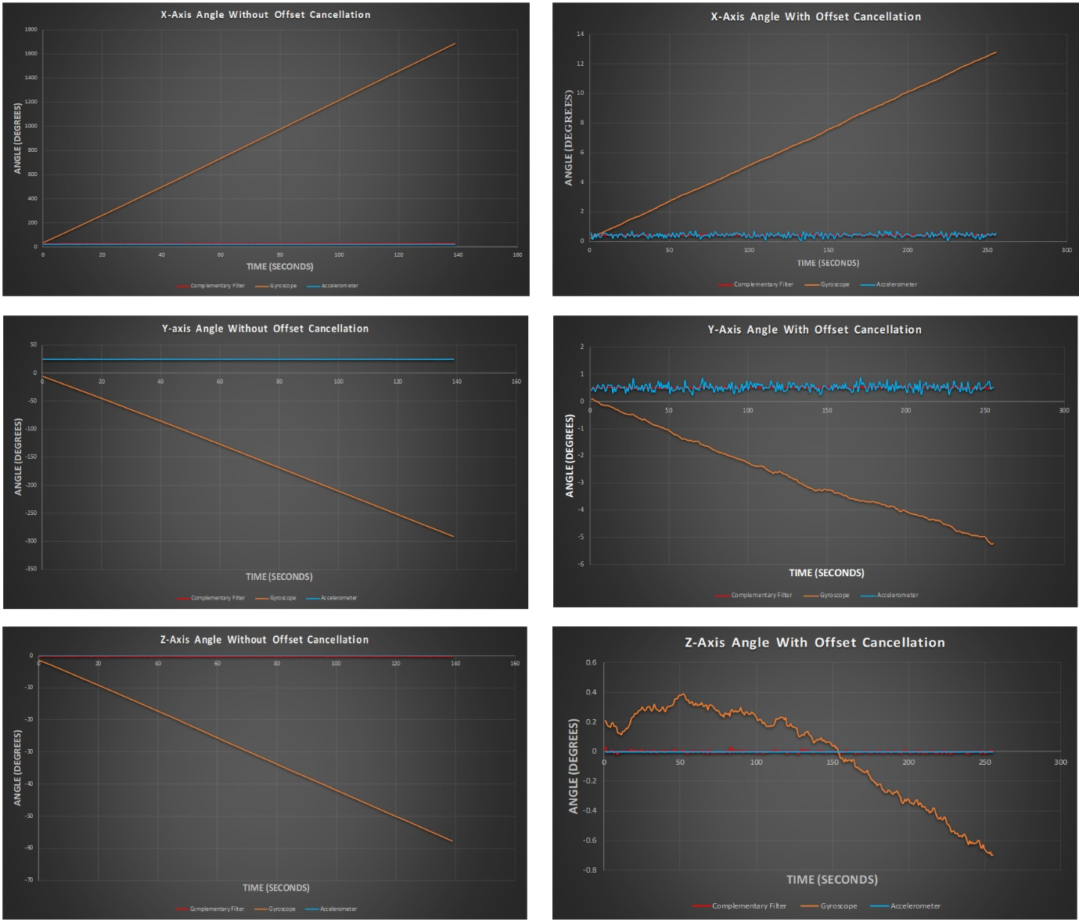

Figure 1: Graphs comparing the orientation angles of all three axes without offset cancellation (Left) and with offset cancellation (Right).

### **Complementary filter and Drift**

#### **Test Setup**

The IMU was left stationary on a flat desk, facing up and allowed to gather samples.

#### **Results**

It can be seen from figure 2 that even though the gyroscope angle drifts as time passes, the complementary filter keeps with the accelerometer data. The fusion of the gyroscope data with accelerometer data makes the complementary filter orientation angle immune to the effects of drift that the gyroscope alone suffers from. See Appendix A for y and z axes drift.

Machine generated alternative text:
X-Axis Complemetary Filter in Static Conditions 
TIME (SECONDS) 
Conv F 

Figure 2: Graph depicting complementary filter angle in static conditions compared to gyroscope and accelerometer angles.

### **Complementary Filter in Dynamic Conditions: Single Axis Rotation**

#### **Test Setup**

During this test the IMU was rotated around a single axis at a time. The Internal measurement unit was rotated by hand (other dynamic tests were performed this way too) and therefore a slight component of rotation was recorded in other axes. Three graphs were plotted for each axis the IMU was rotated about. The first plot is the orientation angle in the axis the IMU was rotated around and the other two graphs plotted are two orientation angles in the other two axes. The IMU was rotated between 90 and -90 degrees approximately in the x and y axes; the z-axis rotation was performed approximately between 180 and -180 degrees. The goal of this test was to test the complementary in dynamic conditions and see how the orientation in the other two axes was affected by this rotation.

#### **Results**

It can be seen from figure three that the complementary filter also provides accurate orientation estimates when rotated about the x-axis. In the 25 second mark in the x-axis graph, the gyroscope angle starts to drift away from the accelerometer angle. Despite this drift, the complementary filter follows the accelerometer tilt. At the 8 second mark, the accelerometer readings become unstable and therefore the complementary filter follows the gyroscope angle more closely instead.

Due to human error and non-orthogonality of the IMU there are changes in angle present in the y-axis. The complementary filter can be seen changing in the manner that the gyroscope angle changes but because the effects of drift are eliminated by the accelerometer angle, these complementary filter changes occur about the accelerometer angle most of the time which shows that the complementary filter achieves the desired effect of eliminating the effects of drift from the orientation of the IMU.

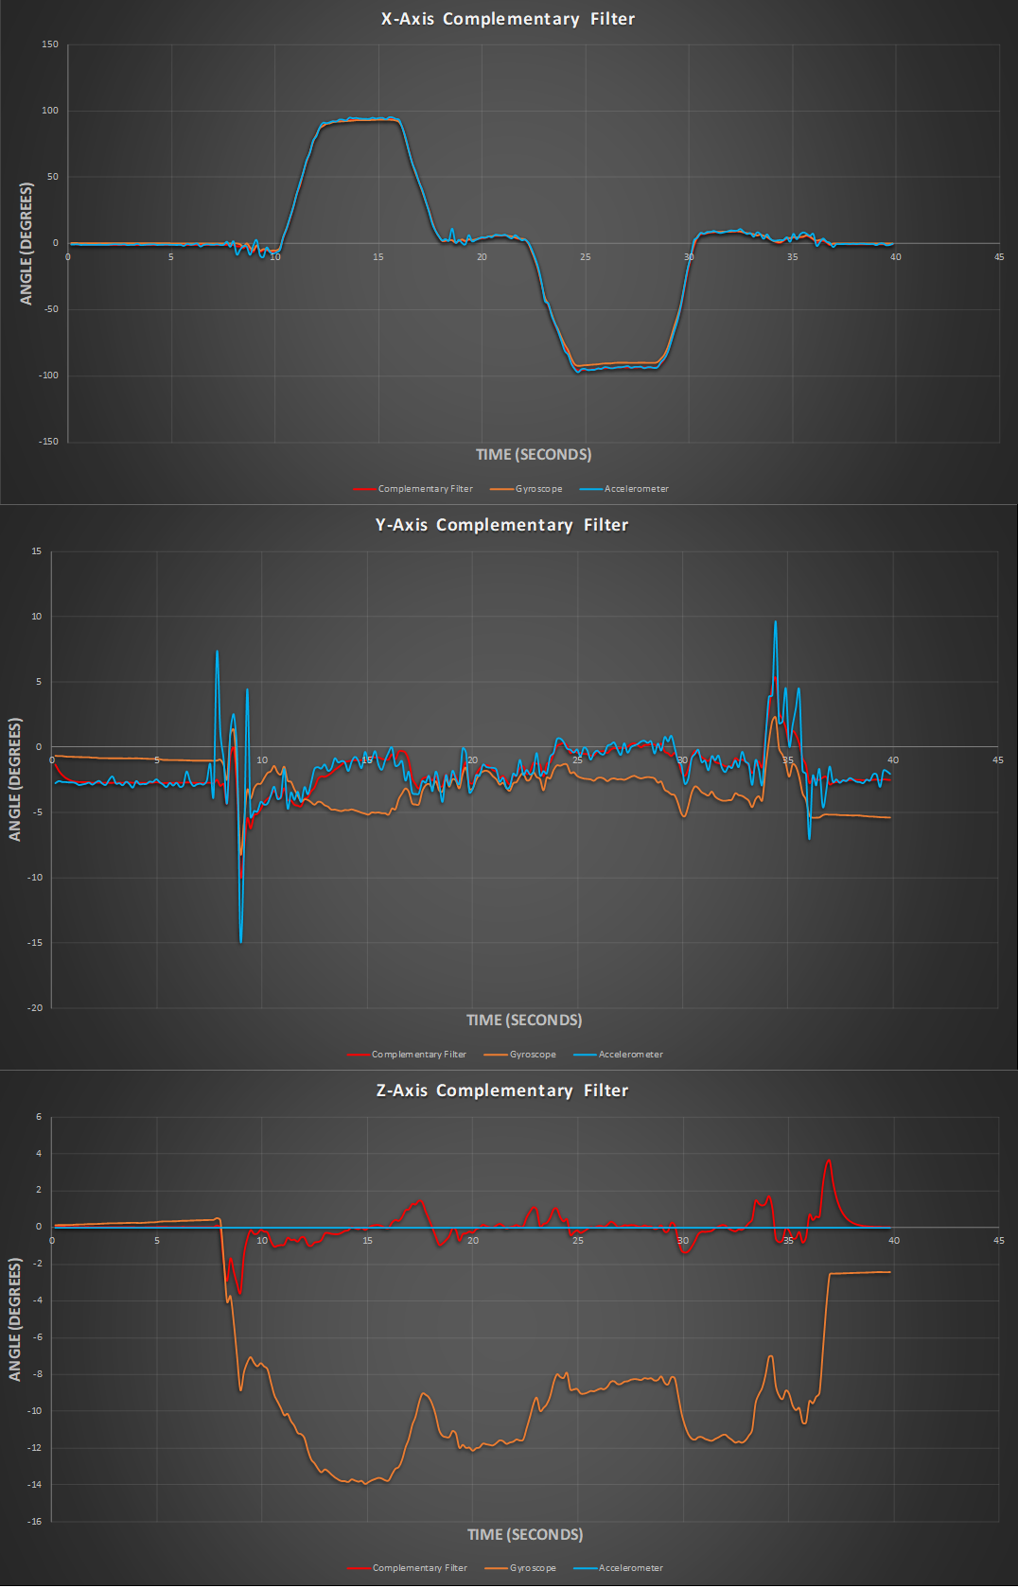

Figure 3: Graphs depicting the orientation of the IMU in all three axes when the IMU is rotated in the x-axis.

Figure 4 depicts the orientation angles of the IMU in all three axes when the IMU is rotated in the y-axis. It can be seen that the complementary filter works as expected when rotated in this axis. A problem occurs when in the x-axis when the IMU begins to rotate in the y-axis in a direction that causes the angle to become positive. When this happens the x-axis orientation angle starts to change in the opposite direction. This change is too large for human error or for non-orthogonality effect and the origin of this error has not been found. This error may be due to the limit of the tangent function in the orientation calculations.

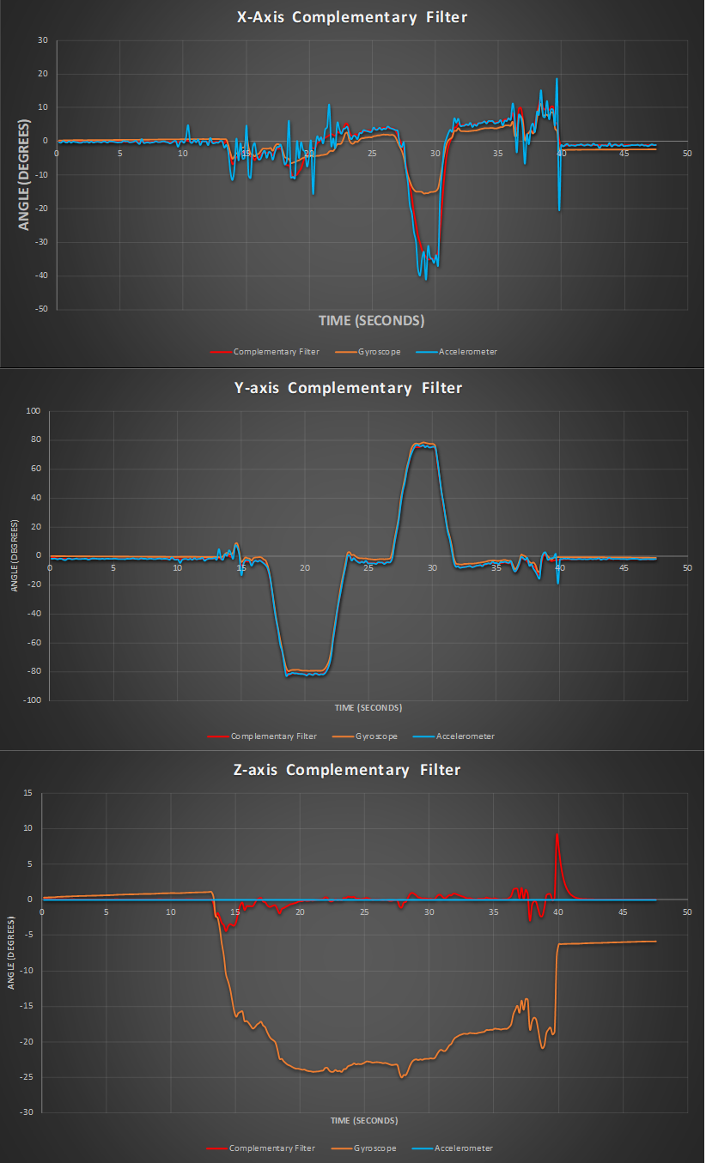

Figure 4: Graphs depicting the orientation of the IMU in all three axes when the IMU is rotated in the y-axis.

Figure 5 shows the orientation angles of the IMU in all three axes when the IMU is rotated about the z-axis. As expected, the complementary filter does not work as expected because the gravity vector does not change when the device is rotated about the z-axis. Despite the gyroscope angle changing as expected, the accelerometer tilt remains unchanged causing the complementary filter to converge back to an angle of zero. This convergence is especially visible on the 20 second mark on the z-axis graph. At that point the complementary filter should be indicating approximately 180 degrees but because of the accelerometer tilt remaining at zero, the angle converges to zero when the IMU ceases to rotate. The changes in orientation in the x and y axes are due to human error as rotating the device purely in the z-axis was difficult.

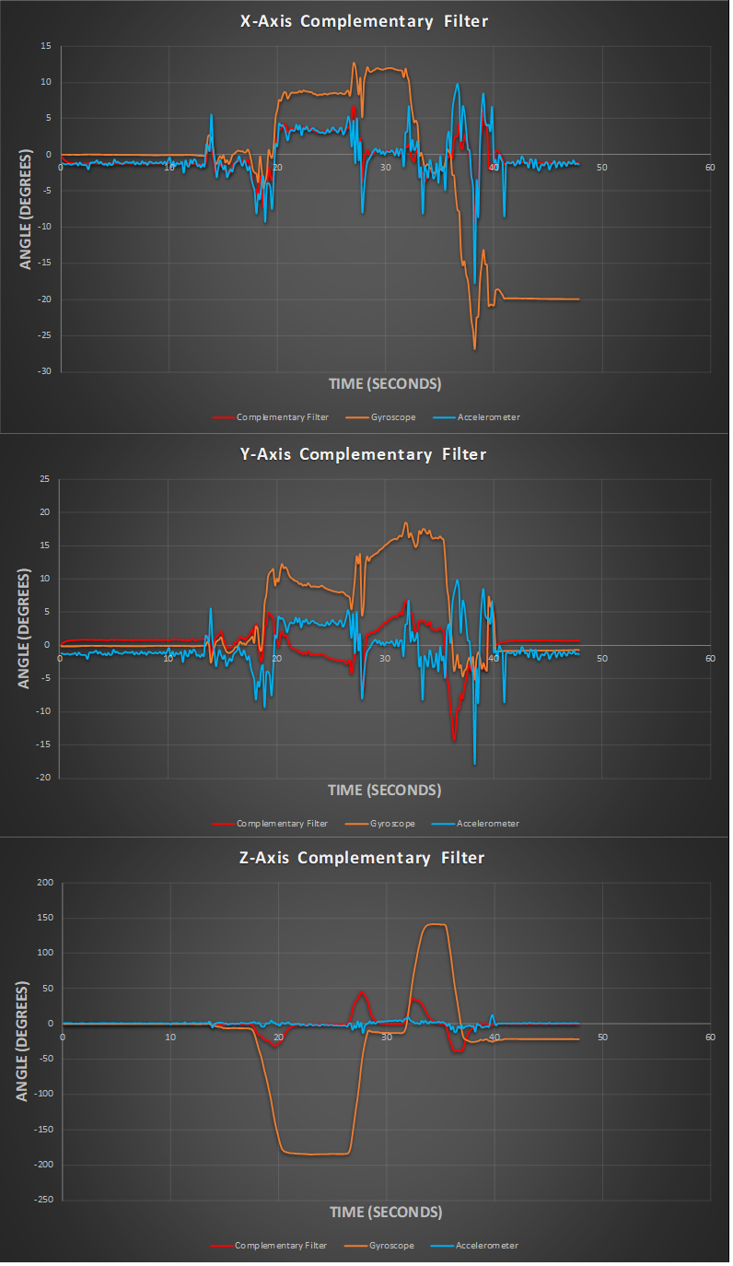

Figure 5: Graphs depicting the orientation of the IMU in all three axes when the IMU is rotated in the z-axis.

### **Complementary Filter in Dynamic Conditions: Rotation About Multiple Axes**

#### **Test Setup**

During this test the internal measurement unit was rotated randomly in all three axes simultaneously.

#### **Results**

As can be seen from figure 6, the complementary filter also applies when the IMU is rotated in all three axes simultaneously. Even though the gyroscope angle drifts, the complementary filter does not experience this drift as it is eliminated by fusion of the accelerometer into the gyroscope angle. Therefore, the complementary filter will always converge to the accelerometer angle in the end when the IMU stops rotating.

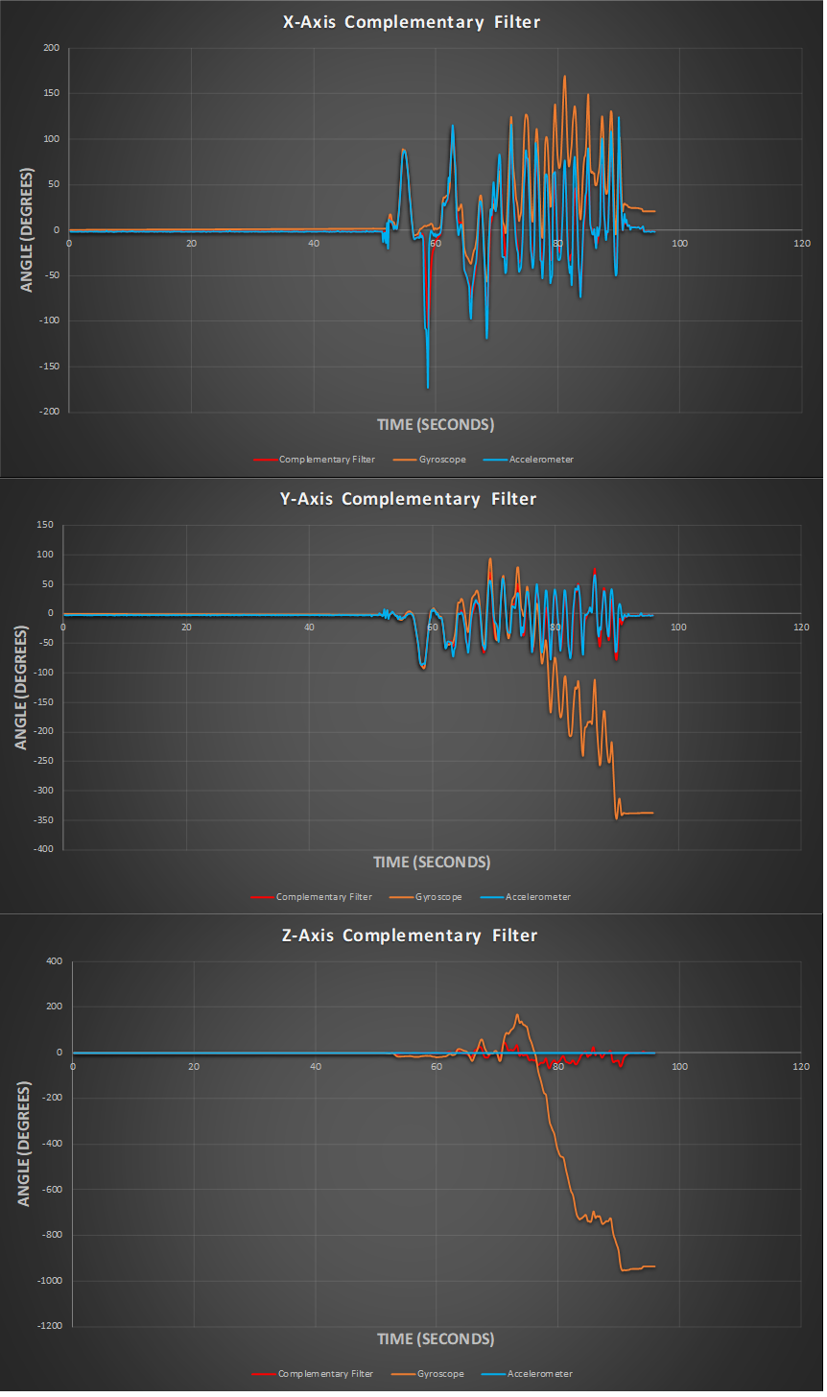

Figure 6: Graphs depicting the orientation of the IMU in all three axes when the IMU is rotated about the x, y and z axes simultaneously.

### **Complementary Filter in Dynamic Conditions: 360 Degrees Rotation**

#### **Test Setup**

During this test the internal measurement unit was rotated 360 degrees in each axis separately.

#### **Results**

Figure 7 depicts the rotation of internal measurement unit about the x-axis. It can be seen that once the angle reaches 180 degrees, the angle suddenly flips in magnitude. This is due to the limits of the ‘atan2’ function, which can only calculate angles between -180 and 180 degrees. If this value is exceeded, a reversal in magnitude will be caused.

z 
so 
Complementary Filter X 
360 Rotation 
TIME (SECONDS) 
Fite r Y 
Complementary Filter Z 

Figure 7: Graph depicting the complementary filter orientation angles in all three axes when the IMU is rotated in the x-axis.

When rotating 360 degrees about the y-axis, the same problem occurs where the x-axis rotation is recorded despite the fact that the IMU only rotates in the y-axis. Figure 8 shows the results of 360 degree rotation of the IMU in the y-axis.

IMU 360 Rotation 
(SECONDS) 
FitterY 

Figure 8: Graph depicting the complementary filter orientation angles in all three axes when the IMU is rotated in the y-axis.

Figure 9 depicts 360 degree rotation about the z-axis. Due to the inability of the accelerometer to sense rotation in the z-axis, the complementary cannot measure the 360 degree rotation in the z-axis.

z 
< 10 
Co mp Fi X 
IMLJ Rotation 360 
TIME (SECONDS) 
Complementary Filter Y 
Co mp Fi Z 

Figure 9: Graph depicting the complementary filter orientation angles in all three axes when the IMU is rotated in the z-axis.

# **Appendix A**

Graphs depicting the orientation angles in the y and z axes of the IMU in static conditions.

Machine generated alternative text:
Y-Axis Complemetary Filter in Static Conditions 
z 
TIME (SECONDS) 
Co mp%l 
ete r 

Machine generated alternative text:
Z-Axis Complemetary Filter in Static Conditions 
-02 
z 
< -0.4 
TIME (SECON DS) 
Conv F 